Customers And Orders
CREATE TABLE Customers (
customer_id INT PRIMARY KEY,
name VARCHAR(50),
city VARCHAR(50)
);
desc Customers;

INSERT INTO Customers (customer_id, name, city) VALUES
(1, 'Arjun', 'Bengaluru'),
(2, 'Sneha', 'Hyderabad'),
(3, 'Rahul', 'Chennai'),
(4, 'Priya', 'Bengaluru'),
(5, 'Kiran', 'Mumbai'),
(6, 'Divya', 'Bengaluru'),
(7, 'Vikram', 'Hyderabad'),
(8, 'Asha', 'Chennai'),
(9, 'Manoj', 'Pune'),
(10, 'Swathi', 'Bengaluru');
Select * from Customers;
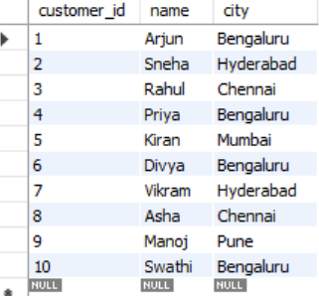
CREATE TABLE Orders (
order_id INT PRIMARY KEY,
customer_id INT,
restaurant VARCHAR(50),
amount DECIMAL(10,2),
order_date DATE,
FOREIGN KEY (customer_id) REFERENCES Customers(customer_id)
);
INSERT INTO Orders (order_id, customer_id, restaurant, amount, order_date) VALUES
(101, 1, 'Meghana Foods', 550.00, '2025-01-01'),
(102, 2, 'Paradise Biryani', 780.00, '2025-01-03'),
(103, 3, 'KFC', 420.00, '2025-01-05'),
(104, 1, 'Empire Restaurant', 300.00, '2025-01-08'),
(105, 4, 'Meghana Foods', 950.00, '2025-01-10'),
(106, 6, 'Truffles', 1100.00, '2025-01-11'),
(107, 7, 'Kritunga', 650.00, '2025-01-12'),
(108, 4, 'KFC', 350.00, '2025-01-14'),
(109, 9, 'Burger King', 270.00, '2025-01-15'),
(110, 10, 'Meghana Foods', 1250.00, '2025-01-16');
Select * from Orders;
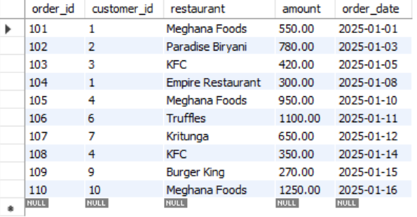
- List all customers who have placed at least one order.
select customer_id, name from Customers where Customers.customer_id in (select distinct customer_id from Orders);
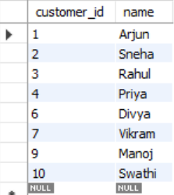
- Find the total amount spent by each customer.
SELECT c.customer_id, c.name, SUM(o.amount) AS total_order_value
FROM Customers c JOIN Orders o ON c.customer_id = o.customer_id GROUP BY c.customer_id;
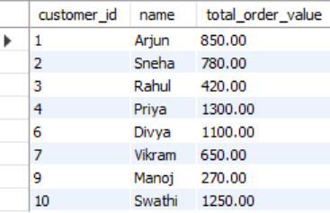
- Display the top 3 customers based on total spending.
SELECT c.customer_id, c.name, SUM(o.amount) AS total_order_value
FROM Customers c JOIN Orders o ON c.customer_id = o.customer_id GROUP BY c.customer_id order by total_order_value desc limit 3;
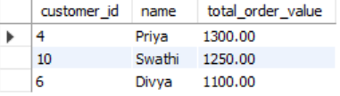
- Retrieve all orders placed in the last 7 days (from latest order date).
SELECT * FROM Orders where order_date >((select max(order_date) FROM Orders) - INTERVAL 7 DAY) order by order_date;
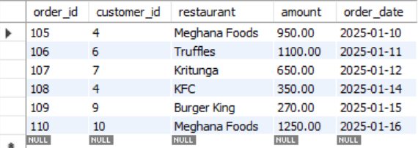
- Show customers who have never placed an order.
SELECT c.customer_id, c.name FROM Customers c LEFT JOIN Orders o ON c.customer_id = o.customer_id WHERE o.order_id IS NULL;

- Find the restaurant that received the highest number of orders.
SELECT restaurant FROM Orders o GROUP BY restaurant order by count(restaurant) desc limit 1;

- List customers from “Bengaluru” who spent more than ₹1000.
SELECT c.customer_id, c.name, c.city, SUM(o.amount) AS total_order_value FROM Customers c JOIN Orders o ON c.customer_id = o.customer_id where city = "Bengaluru" GROUP BY c.customer_id having SUM(o.amount) > 1000;
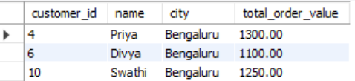
- Show the total number of orders placed per city.
SELECT distinct c.city, Count(c.city) AS City_Orders FROM Customers c JOIN Orders o ON c.customer_id = o.customer_id group by c.city;
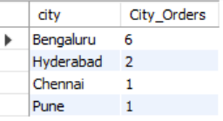
- Find the average order amount for each restaurant.
SELECT distinct restaurant, AVG(amount) AS City_Amount FROM Orders group by restaurant;
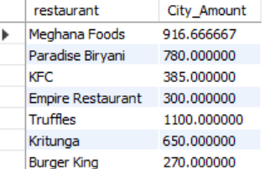
- Identify customers who placed more than 5 orders.
SELECT distinct c.customer_id, c.name, Count(o.order_id) AS Customer_Orders FROM Customers c JOIN Orders o ON c.customer_id = o.customer_id group by c.customer_id having count(order_id) > 5;


